

YEAR: 11

SUBJECT: 2B Human Biological Science

TEST: Task 14 Variation, Mutation and Pedigrees
TIME: 60 minutes
QUESTIONS: 20 Multiple Choice, 6 Short Answer, 1 Extended Answer
TOTAL MARKS: 65

DO NOT WRITE ON OR MARK THIS PAPER

SECTION ONE—MULTIPLE CHOICE (20 marks)

This section has 20 questions. Answer all questions on the separate Multiple-choice Answer Sheet provided.

Question 1
A DNA molecule may be made using which of the following?
1.uracil 2.adenine 3.thymine 4.guanine 5.cytosine
- 1, 2, 3, 4
- 2, 3, 4, 5
- 1, 3, 4, 5
- 1, 2, 3, 4

Question 2
If you were examining a sequence of base pairs in a DNA molecule, which sequence would be possible in a properly constructed double-stranded DNA molecule?
- A+T, C+G, T+A, T+A, G+C
- A+T, G+C, C+C, T+U, G+T
- G+C, C+G, A+U, U+A, T+A
- G+G, C+C, A+A, T+T

Question 3
What do you call a cell's genetic material during a non dividing phase?
- chromatids
- RNA
- chromosomes
- chromatin

Question 4
How many chromosomes should a human skin cell have?
  - 21
  - 23
  - 23 pairs
  - 46 pairs

Question 5
An allele is best defined as
- a lethal recessive phenotype
- a lethal dominant phenotype
- a type of gene found only on the sex chromosome
- an alternative form of gene at a given locus

Question 6
In humans, a male baby results when
- the egg is fertilised by a sperm carrying a Y chromosome
- The egg is fertilised very early in the menstrual cycle
- The unfertilised egg contains a Y chromosome
- The woman’s vaginal fluid is very acidic (low pH)
Question 7
Which of the following characteristics is definitely solely genetically determined?
- blood group
- intelligence
- ability to succeed at sport
- personality

Question 8
Which of the following is true about mutations?
- they are always harmful
- in most cases they are not permanent
- point mutations involve one base only
- chromosomal mutations affect only one gene

Question 9
During the process of non-disjunction
- chromosomes can fail to separate in the first phase of meiosis
- chromatids can fail to separate in the first phase of meiosis
- crossing over of the chromatids occurs
- chromosomes assort independently of each other

Question 10
Stem cells can be obtained from three main sources, these are
- umbilical cord blood, bone, skin
- adult, blood, hair
- hair, skin, embryonic
- umbilical cord blood, embryonic, adult

Question 11
Germ line mutations involve
  - the formation of gametes with changed DNA
  - development of cancerous growths
  - general body cells
  - mutations that affect only the individual in which they originated

Question 12
As a result of the Human Genome Project
- all human diseases can now be cured.
- the genes in all 46 chromosomes have been mapped.
- the sequence of proteins in all human chromosomes is known.
- faulty genes can now be corrected.

Question 13
A Co-dominant genetic condition is one in which
- the heterozygote show the effect of two different alleles
- there are two possible ways to combine alleles
- the homozygote has inherited different alleles from each parent
- one allele completely hides the effect of another allele

Question 14
Mutations to genes on the sex chromosomes are likely to be expressed
- equally in males and females
- more frequently in females
- more frequently in males
- not at all, because they are invariably lethal

Question 15
Sex selection can be used to reduce the chances of inheriting a genetic condition. Which of the following techniques is the most effective method of achieving sex selection?
  - timing of sexual intercourse in relation to ovulation
  - manipulating body temperature of males and females
  - choosing a diet that increases the chance of a particular sex being selected
  - testing an embryo resulting from in-vitro fertilisation (IVF) before implantation

Question 16
Treating a disease with gene therapy means
  - replacing a missing protein with a functioning protein.
  - replacing faulty genes in body cells with healthy ones.
  - injecting a hormone to replace one that is lacking.
  - inserting extra genes into the DNA structure.

Question 17
Red-green colour-blindness is an X-linked recessive disorder. A mother with this condition will pass this allele to
- her daughters only
- all of her children
- her sons only
- none of her children

Question 18

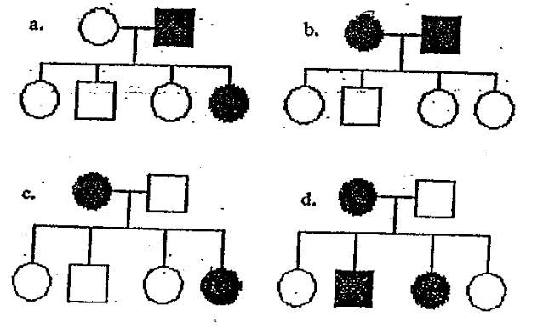

Which of the pedigrees above is consistent with the inheritance of a recessive characteristic controlled by a gene on the X chromosome? Shaded individuals possess the trait.
- A
- B
- C
- D

Question 19
Consider the following pedigree of a family showing the inheritance of an autosomal recessive trait. Shaded individuals possess the trait:

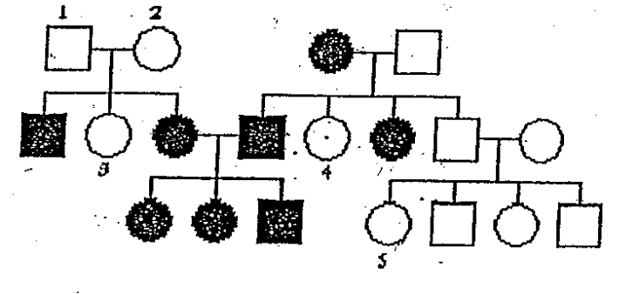

With regard to the trait in question it would NOT be reasonable to assume that:
- individual 4 is heterozygous
- individual 5 is homozygous
- there is a probability of 2/3 that individual 3 is heterozygous
- both individuals 1 and 2 are heterozygous

Question 20
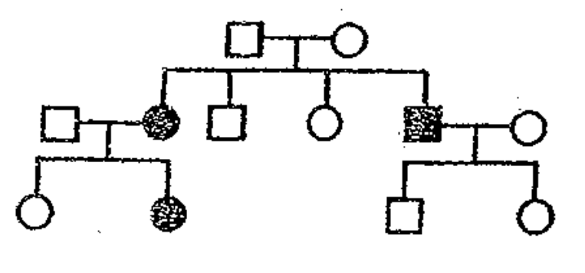

What is the most likely mode of inheritance for the shaded characteristic shown in the diagram above?
- an autosomal dominant gene
- an autosomal recessive gene
- an X chromosome-linked gene
- a Y chromosome linked gene

Task 11 Variation, Mutation and Pedigrees Test:
2B Human Biological Science
2014
ANSWER BOOKLET

NAME:
FORM: DATE:

Multiple Choice Short Answer Extended Answer Total

/20

/35

/10

/65

SECTION ONE: Multiple choice answers
Cross (X) through the correct answer.

1 | a | b | c | d |  | 11 | a | b | c | d
2 | a | b | c | d |  | 12 | a | b | c | d
3 | a | b | c | d |  | 13 | a | b | c | d
4 | a | b | c | d |  | 14 | a | b | c | d
5 | a | b | c | d |  | 15 | a | b | c | d
6 | a | b | c | d |  | 16 | a | b | c | d
7 | a | b | c | d |  | 17 | a | b | c | d
8 | a | b | c | d |  | 18 | a | b | c | d
9 | a | b | c | d |  | 19 | a | b | c | d
10 | a | b | c | d |  | 20 | a | b | c | d

SECTION TWO – SHORT ANSWER
Six questions worth 50 marks
Complete all answers in either blue or black pen.

Question 21
Explain the difference between a single gene disorder and a chromosomal disorder. Give an example of each. (6 marks)

Question 22
Complete the following table about stem cells. (6 marks)

Stem Cell Type | Potency
Totipotent
Pluripotent
Multipotent

Question 23
Draw a correct pedigree from the following information, using the initial letters of the names of the people involved (eg 'N' for Norman). A freehand drawing is acceptable. (5 marks)

Alan is married to Beatrice. They have five children born in the following order, Cheryl, Douglas, Edward, Frederick and George. Sadly, Frederick died as a baby. Cheryl is married to Henry and George is married to Isabelle. Cheryl and Henry have two daughters, Julie (eldest) and Kate. Leonard and Martin are brothers. Their mother is Isabelle. The second sons and first daughters all have a recessive genetic condition.

Question 24
The pedigree below shows the inheritance, within a family, of a very rare disorder called Gingus Rangus Monobrowii where the affected individual has red hair and only one eyebrow.
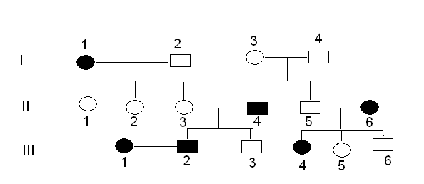

- Is the disorder inherited as a dominant or recessive trait? (1 mark)

- Explain how you arrived at your answer in (a) (1 mark)

- Is the trait autosomal or X-linked? (1 mark)

- Explain how you arrived at your answer in (c). (1 mark)

- Using R and r what are the genotypes of the following individuals (3 marks)
    - I.2
    - I.3
    - 1.4
    - II.3
    - II.5
    - III.3
Question 25
The pedigree shown below represents the inheritance of a genetic condition that affects normal vision. A student examined this pedigree and concluded that the condition is a sex-linked recessive disorder. On the basis of this information, answer the questions below. In your analysis, use the letters N or n
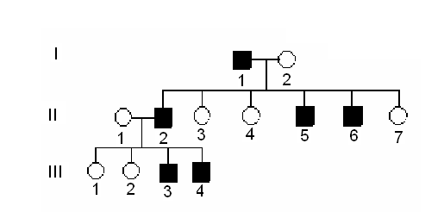

- What is the probability that individual II-4 is a carrier? Show your working. (3 marks)

- What is the genotype of all the affected males? (1 mark)

- If individual III-2 married and had children with an infected person, what is the chance that their child will have the condition? Show your working (3 marks)

Question 26
The ABO blood grouping system displays two phenomena in genetics. Explain the following terms and give an example using the ABO system.

- Multiple Alleles (2 marks)

- Co-dominance (2 marks)

SECTION THREE – EXTENDED ANSWER
One question worth 10 marks
Answer question using blue or black pen and pencil for the diagrams.

Question 27
Malaria is a parasitic disease widespread in the tropics and transmitted by mosquitoes. Sickle-cell anaemia is a recessive gene disorder found in a relatively high proportion (up to 40%) of people from tropical Africa and from countries around the Western Indian Ocean. People carrying a single copy of the gene, (Aa), are generally healthy and are less susceptible to malaria than people who do not carry the gene (AA). People who are homozygous for this gene (aa) are also less susceptible to malaria, but develop a form of anaemia that is almost always fatal.

Imagine you are a genetic counsellor dealing with a couple in one of the countries above.
A couple wanting to have a family presents for advice. Both are known to be heterozygous for the sickle cell gene. Calculate the percentages of the likely genotypes of their children, and describe the phenotypes and survival prospects of these possible offspring.

